**Idea and Practical:**

1. Matrix banana he
2. Uske phle error struct banana he ,and matrix ki har function me uska use krna he, as per the discussion.
3. Matrix k liye 2d array lgega, but AI k case me length width to vary rahegi , to dynamic bnana padega.
4. Data k liye matrix and vector library banana and we go for dynamic array, isme bhi 2 style me bna skte he,
5. A[][] wala style jisme array of pointer , like user pass r*c then r size ka ek array of pointer then, against each pointer[element of pointer of array] we will create an array[that will store the actual value] of size c and assign the base address to pointer in array of pointers.

So here each element of array of pointer is int * can hold address of int type memory or base address of int array.

Now we need to manipulate this array of pointer for this we can use a variable like this int **arr;

Means arr can store the address of variable of type (int * ) or base address of array of type int *

Arr ek pointer he jo pointer ka address hold krega ya array of pointers ka base address, and ye arr jis pointer ka address hold krega vo pointer int type k variable ka address ya int type k array ka base address store krega and usko point krega, structure will look like this

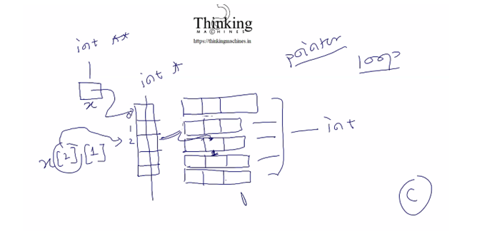

1. A[] : isme 2D jesa kucn nahi rahega r*c ki jo value aayegi us length ka allocation and then to manipulate hum kuch functions likhege jo r and c index ka use k ke kisi particular block/ dabbe ko manipulate krega.

Hum log B wala tarika use krege and functionality ko wrap kr dege to user vo out of bound wali harkat nahi kr payega and uski harkto ko message me convert kr k us tak pahuchane k liye hi error struct bna rahe he.

Mtlb usko bolege ki humare functions use karo and ek error ka structure bna k uske address to taki kuch error aaye to hum us address pr error message likh de and aap usko dekh k pata kr sko ki kya issue aa raha he.

Error struct ko bhi wrap krege with functionality like has_error() get_error() etc.



Problem:

If user write struct matrix k this means user tried to create structure block In static way

But what if user write **struct matrix *k = create_new();** isme user ko only pointer bnanare ka adhikar, struct vo function likhne wala bnayega.

But esa kese possible kre?

Ans: ek header file me declaration de do lile **struct matrix** means now user can create pointer but cant create object like **struct matrix k** because iski definition header file me to he hi nahi.

Only declaration he.

To simple he hum user ko header file dege and definition kahi or likhege. Esa kr k humne encapsulate kr diya.

**Step 1: Folder structure**

Lets create error structure:

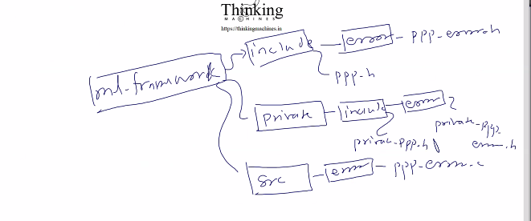

This will be folder structure

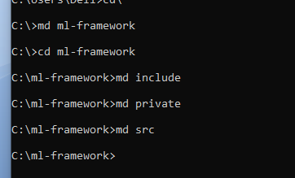

Ab include me ghus k uska sub structure

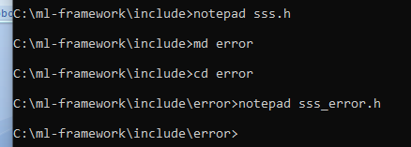

sss.h is main file that will include all header files and user has to only include this sss.h while working

then we created another folder named as error and created one file inside it that is sss_error.h

here sss is prefix for our library name system.

**Problem:** jb hum error k functions likkhege like

[**Create**, Clear, **Destroy**, Set – in private header file, **Get** ,hasError()]

Here all functions are useful for lib user but setError() is not usefull for lib user coz setting error is work of framework creator.

To iske humko isko private rkhna pdega and that’s why we created private folder.

Now create structure of private folder: uska prefix rahega private so final prefix bnega private_sss.

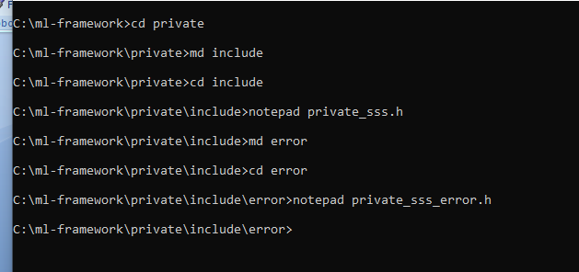

Come come

Ab include ho gaya private ho gaya ab src ka structure: isme saari technology wali files jinka ya to executable version ya obj files version user ko dege.

Executable to execute directly, obj files version user can import the existing code to use it in there code as lib.ye wala user kese compile krega ye dekhna he.

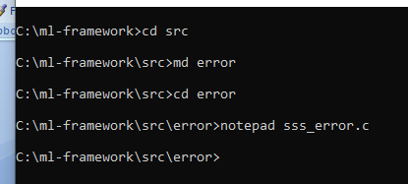

Ye bn gaya src ka bhi structure.

**Next**: kk abhi int ko portable bnane k liye ek or implementation he stdint.h

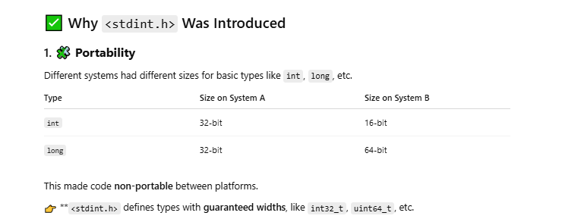

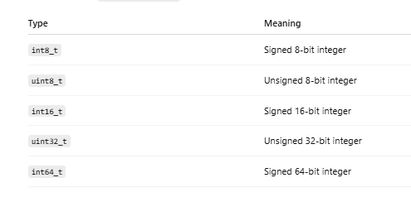

Abhi hum unitX_t ye use krege coz hume signed bit se mtlb nahi he.

Step 2 : Code implementation after creating folder structure

Mai Rough: [create header files and source files for error, create private header files for error,

create header files and source files for matrix , create private header files for matrix if required,]

write code in matrix to read from our own format and csv format]

1. **Main header file sss.h me ye code**

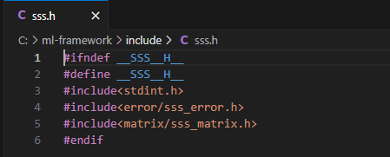

Not e: __SSS__ is the standard format which can conflict with internal header files so we added H__ at the end to make it unique. And same we did for others

Note stdint ko yaha bi add kiya

1. **Sub header file for error that is sss_error.h**

Jb bhi kisi pointer ko dereference krna he to vo kis type ka he us type k basis pr chunk size pta kiya jaata he ki kitni memory read krna he.



Detroy() method ki story:

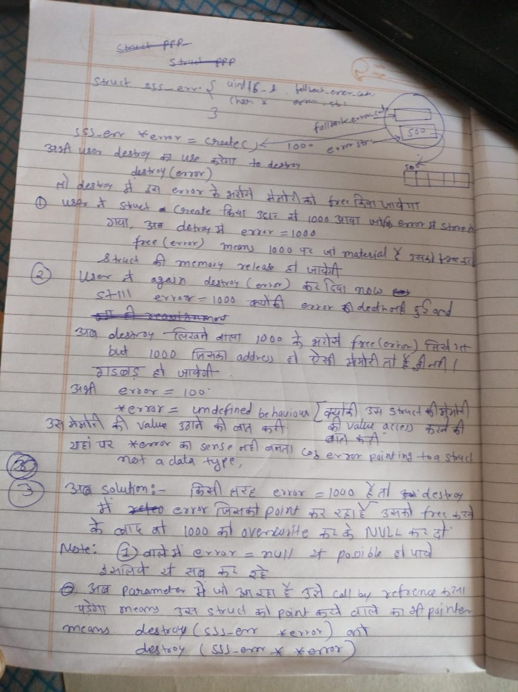

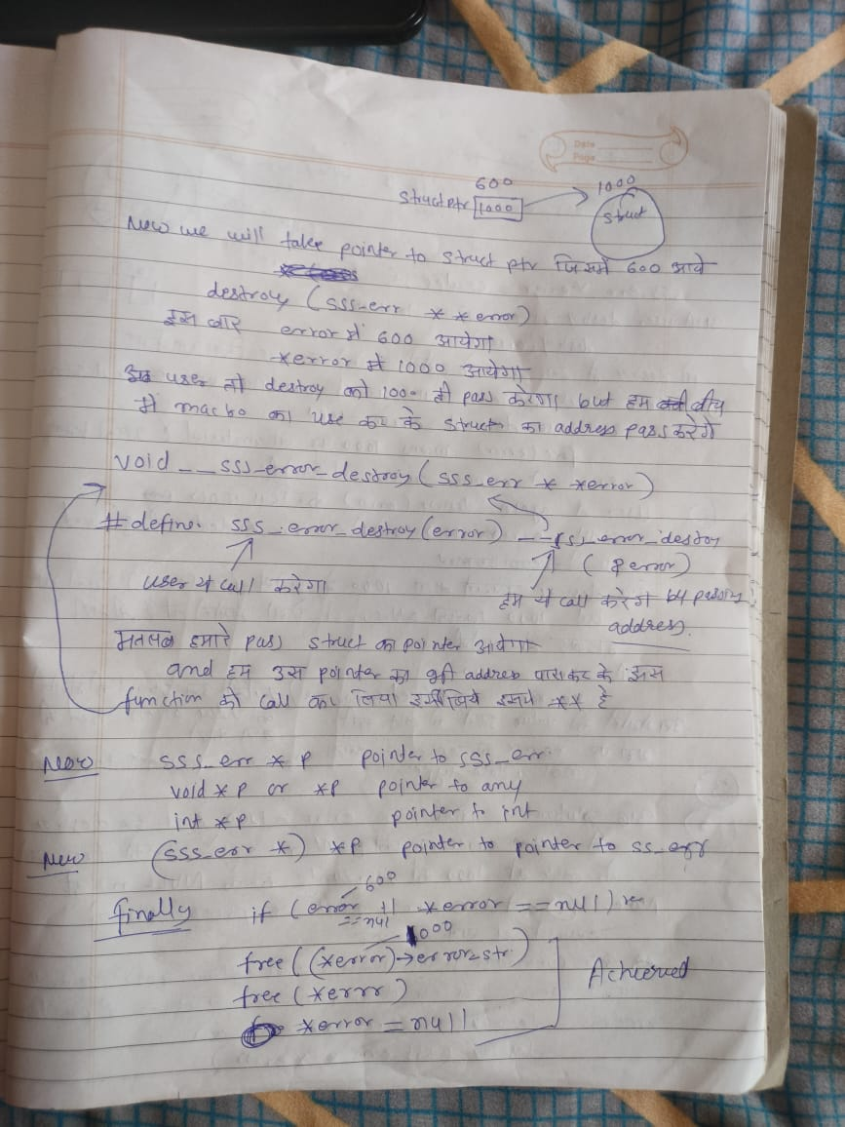

Code for sss_error.h

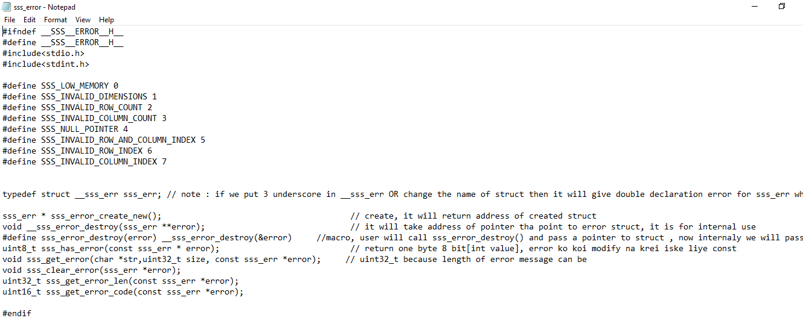

1. **Privat wali header file private_sss.h**

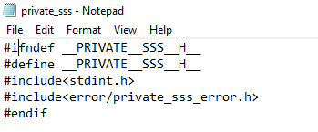

1. **Private wali private_sss_error.h**

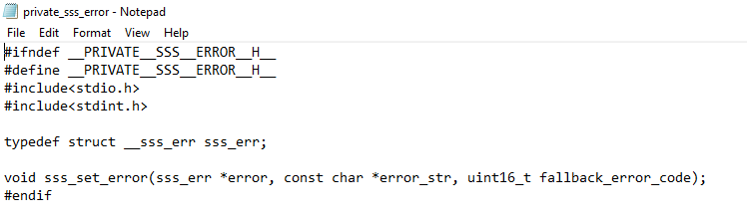

Idr unit16_t means max 65535 error code hum accept kr rahe he, bahut he, 5 digit ka error code 16 bit.



1. **Ab ghuste he src folder me and code implementation krte he : sss_error.c**



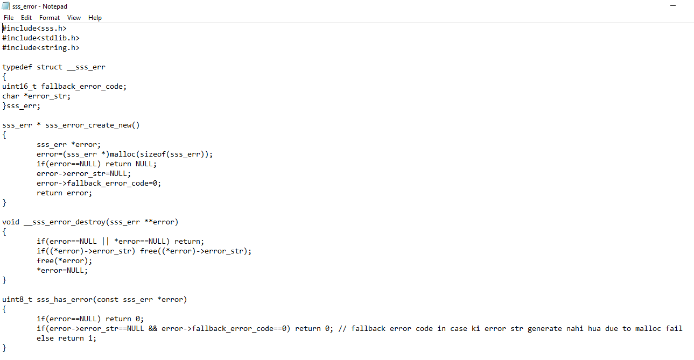

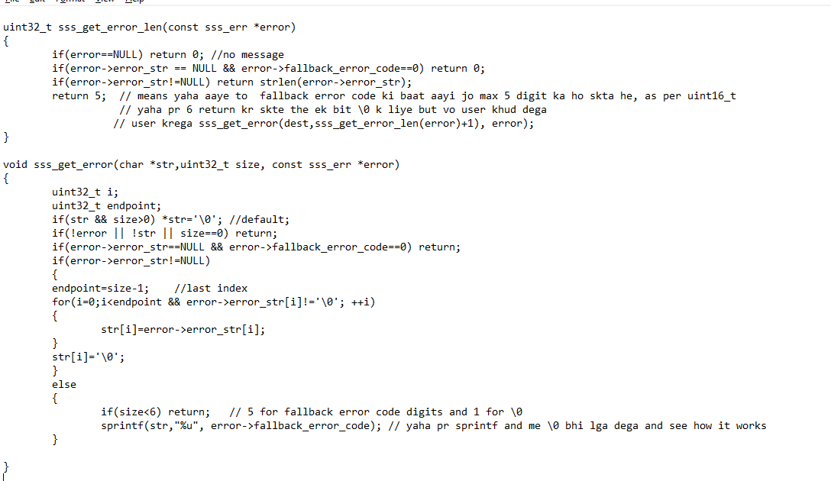

Here in get_error_len why we choose return type as uint32_t?

Note: here _t means type from typedef

Range of uint32_t is 0 to 4,294,967,295 means length of error mesaage can be 4294967295 characters.

**Get Error with fallback error code**: jb user uska pointer dega and size dega ki is size ka chunk he isme error ka content copy kr do .

But humko error code handle krna he,

Yaha 4 if condition lagi he

1. Agr user ne pointer null nahi diya and size bhi di to set empty string
2. Error, size, str teeno me se ek bhi nahi to return and str hoga to default empty to set he hi step 1 me
3. Ye condition he vo error me malloc fail ho jaye tb, and is case me errorcode 0 rahega low memory. Is If me fasa to simply return coz is case me user ka error code error struct me set ho chukka he.
4. Agar error me errorstr he to then copy ka kaam. And isi k else me tb jayega jb errorstr null to fallback error code daal dege user ne jo string diya usme , ye vo user ki galti wale code rahege like invalid index ,etc.

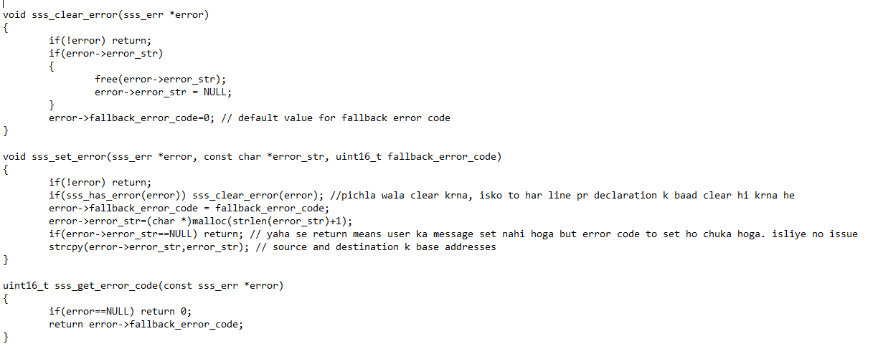

Errorcode uint16_t because it can expect range 0 to 65535 and we are expecting there can be 65 thousnad + error codes that’s why we took uint16_t

Seterror() ka first version ese bnaya tha

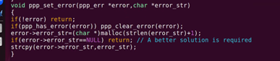

But isme issue tat ki yadi error str k liye mem allocate nahi hui to user ko kese pta chlega ki kya error he.

To uske liye error struct me ek member add kiya fallback error code kr k. taki message na mile tb bhi error code to mil hi jayega.

And method me bhi ek parameter add kiya to receive the error code.

Ab error code set krege then str k liye mem allocate krege , fail bhi ho gaya to error code to set he. And return ho jayege .

Agr allocate ho haya to message bhi copy kr dege.

Now user ko ye saare code documentation me dege.

Ab seterror to framework bnane wala use kr raha he baat krte he geterror ki ki isko kese handle kre?

Testing k liye main function in same file, later remove it while distribute as lib nahi to multiple main wala issue aa jayega. More than one entry point function.

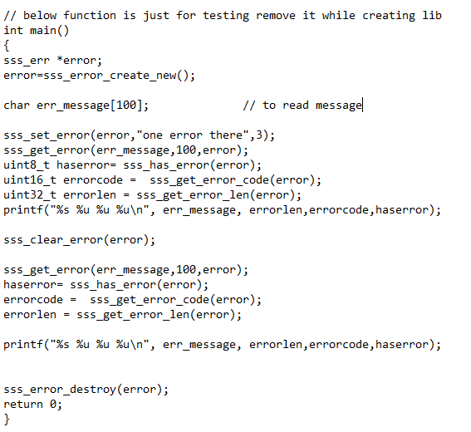

Is function ko testcases folder me test_error.c me likha he step 12 me.

Abhi isko yahi compile kr lete he for testing

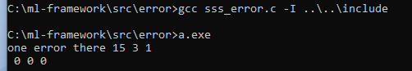

//come come

1. **Next : create header file for matrix**

Create folder structure

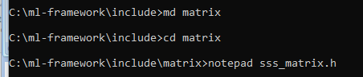

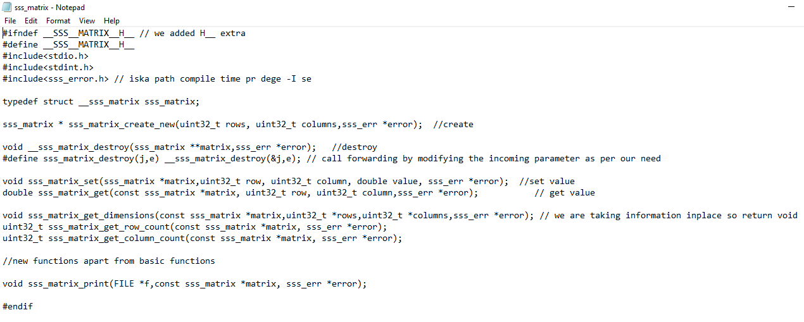

Yaha pr ye function bnaye

Create, destroy, setvalue, getvalue, get dimension, get rowcount, get columncount, total 7 functons.

1. **Ab is header file ko main wali me include krte he:**



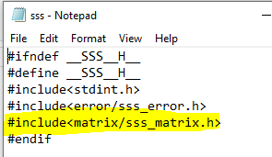

1. **Ab matrix ki source file bnate he.**

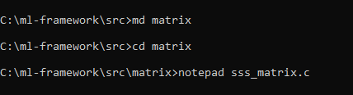

What can be basic checks while creating matrix:

1. User passed rows and columns 0
2. User passed rows as 0
3. User passed columns as 0
4. If all above good then create matrix
5. If step 4 fails means matrix=null, low memory and matrix not created , error set kr k null return , we are returning because return type is not void
6. If step 4 good

then allocate a memory for data and assign it to pointer of matrix struct

Here data is pointing to grid [internally ek flat array of size r*c]

1. If step 6 fails means matrix->data=null, then again set error low memory and return null.
2. If step 6 good then assign values of rows and columns came as param to rows and columns property of matrix struct.

And simply return the matrix pointer.

Header

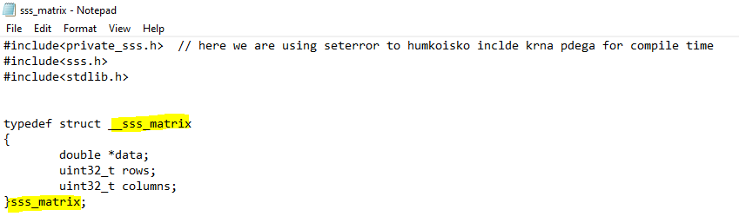

Create:

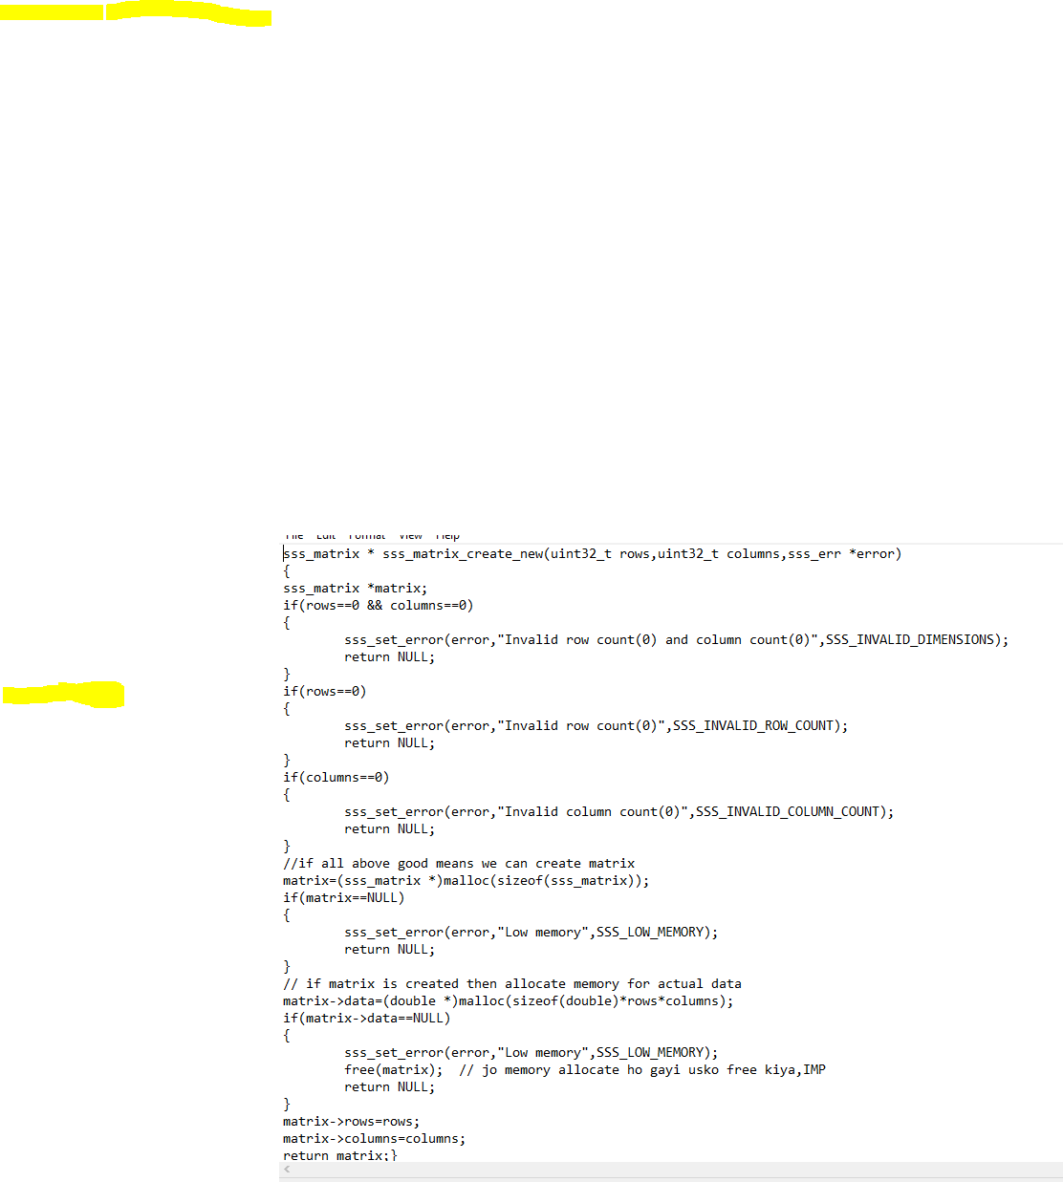

Destroy:

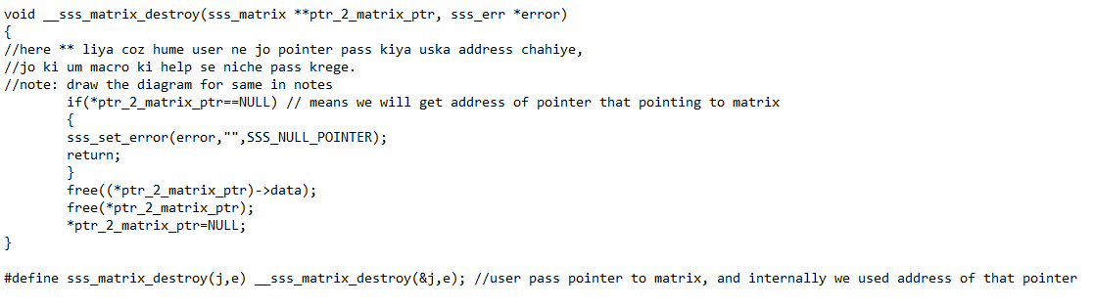

Set:

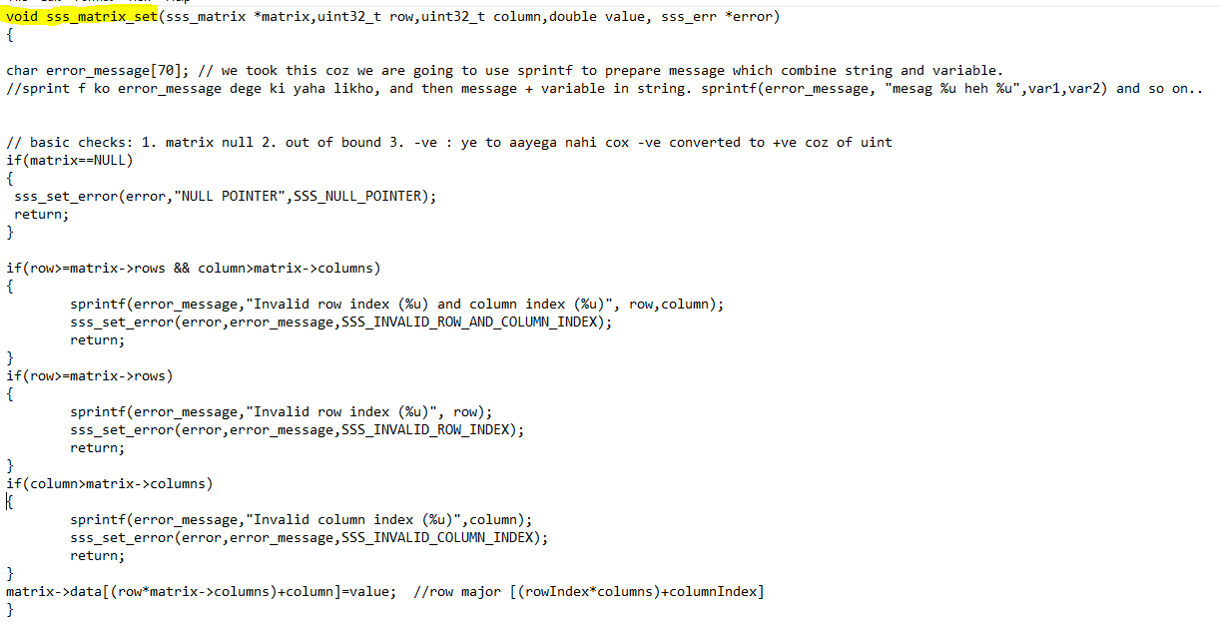

Get:

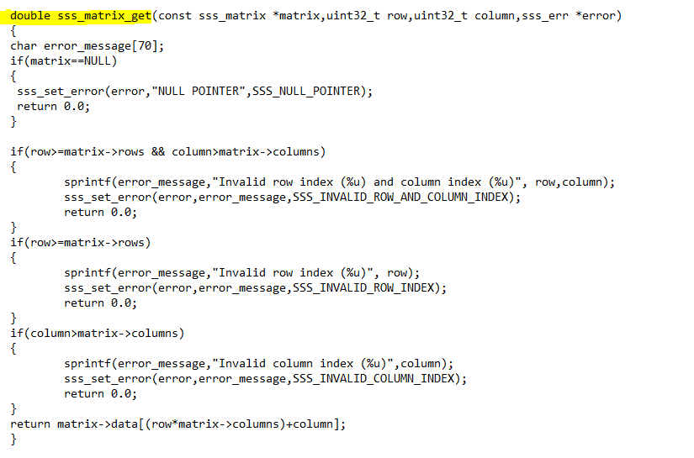

Get dimensions, rowcount, columns counts:

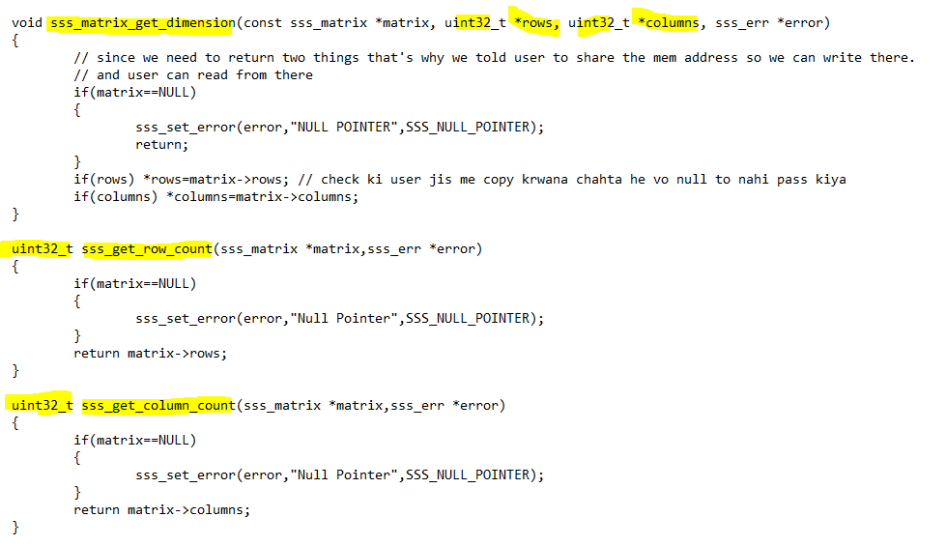

Print matrix:

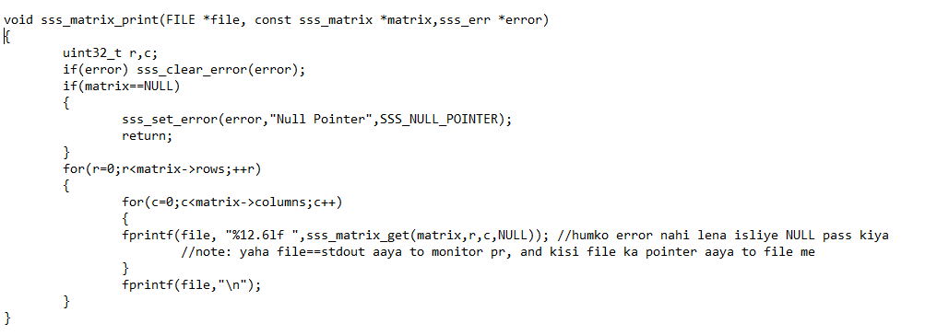

1. **Before compile we need to add error codes for error messages in error.h file**



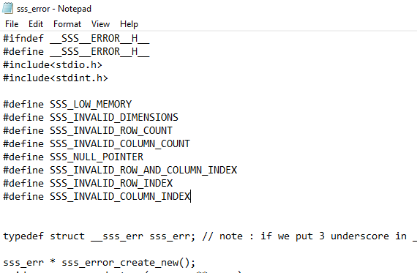

We will include more as per the need comes

1. **Matrix.c k basic functions ka testcase :**

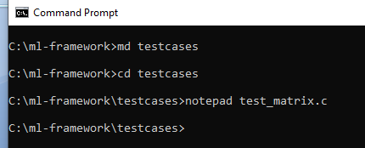

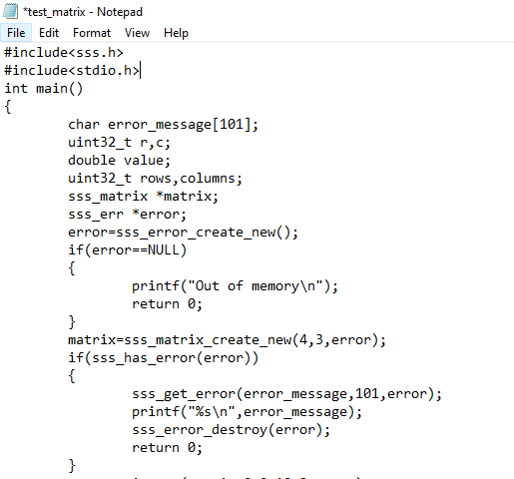

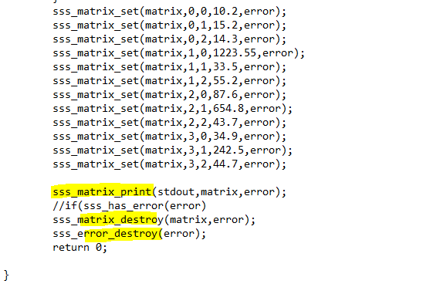

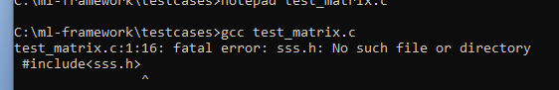

1. **Library bnane k stpes**

Now we have to create library and then have to give path at compile time.

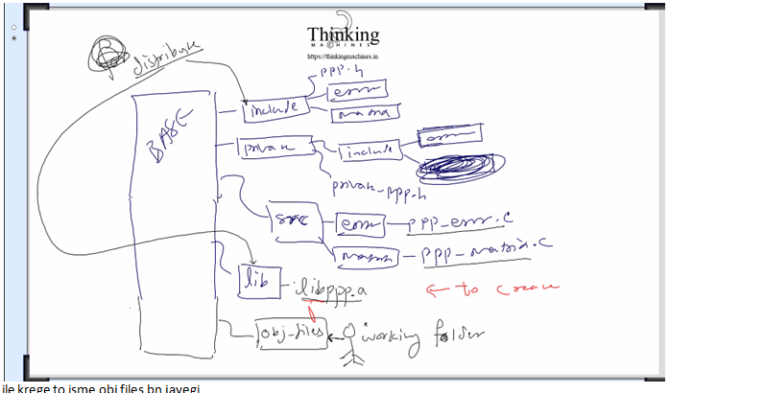

1. Create a folder obj-files and go there

And fire a command to create object files for error.c and matrix.c

Note: gcc -c, here -c is option to create obj files

Create obj file for error.c:

gcc -c ../src/error/*.c -I ../include -I ../include/error -I ../include/matrix



../ means ek ghar piche means ml-framework folder me.

../../2 ghar piche ,

./ current folder me

../src means ek ghar piche src folder me

../src/error/*.c means ek ghar piche src me error me saari c files

Now We used sss.h and inside sss.h we used sss_error.h and sss_matrix.h so in teeno ka path dena padega

So -I krke teeno ka path diya.



Ye bn gayi obj file for error.c

1. Now create obj file for matrix.c



Since matrix k case me humne private wali bhi use kri he to uska bhi path dena hoga



Private folder me jo header file he uska bhi path.

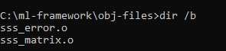

now we have obj files created for both source files matrix and error.

Ab in sb obj files ko lib folder me daalte he

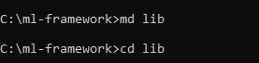

Now command to create lib of obj files



Esa kr k humne ar name k bhaiya ko command ine argument k taur pr teen chize di

1. Kya krna he : rcs
2. Kaha krna he: destination [../lib/libsss.a], ek ghar piche lib name k folder me libsss.a bna k usme is folder ki saari obj files daal do
3. Source: *.o saari obj files in current foder



Ye bn gayi library: ab iska use testcases me krege.

1. **Now matrix.c ka testcase chlate he**



Note: main only testcase me hi likhna he lib ki kisi bhi c file me nahi

Remove main() from c files of library

Us error wale test case ko testcase me separate file bna k likho: test_error.c naam se



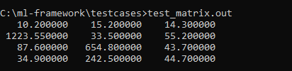

Matrix.c ka testcase run successfully

1. **Process to repeat when doing change in any source file**



1. gcc -c ../src/error/*.c -I ../include -I ../include/error -I ../include/matrix
2. gcc -c ../src/matrix/*.c -I ../include -I ../include/error -I ../include/matrix -I ../private/include
3. del ..\lib\libsss.a Note: file system me \ and path me / use hota he in window cmd prompt.
4. ar rcs ../lib/libsss.a *.o

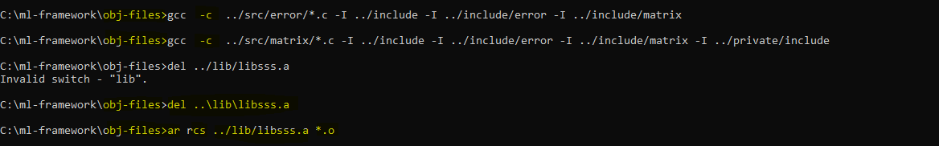

Ye sabhi kaame obj-files folder me hoga

Now we can run the testcases.

**How include system works in c:**

1. sss.h me set_error() define kiya and private_sss.h me declare kiya

to sss.h me private_sss.h ko include krna hoga esa nahi he

because yaha koi interface wala kaam nahi he

ye to baad me dono file merge hokr declaration and definition dono ek hi file me aa jayegi

1. testcases ki test_error.c me private_sss.h ko include krna pda coz ye error aa rahi thi

kyuki compilation k time sss_set_error() kahi nahi mila coz vo to private folder me he and not in the include folder

That’why humko private_sss.h from private folder and sss.h form include folder dono ko add krna hpdega is testcase file me

1. test_matrix.c me iski jarurat nahi lgi coz humne testcase wali c file me set_error() ka use hi nahi kiya.

Haa matrix.c source file me humko private_sss.h ko include krna pdega.

1. Achha agar yahi error wala testcase hum error.c ki source file me krte to vaha private_sss.h ko include krne ki jarurat nai pdti coz source file se definition utha leta.
2. Ab humne jin jin files ko include kiya he unka path bhi dena pdega compile time pr , phir chahe vo source file compile kr rahe ho lib bnane k liye

Ya test file compile kr rahe ho

Path dene k liye –I ka use

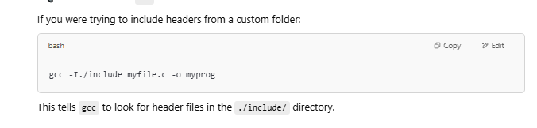

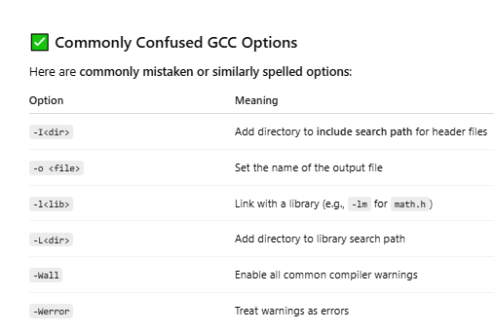

1. **Batch files:**
2. To create library:



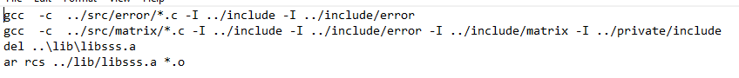

Here while creating obj files we used option –c

For creating obj of error *.c we only need to tell directory for error header files

For matrix *.c we need to tell directory for error, matrix, private as well coz we used seterror().

Then delete current lib and then create new.

Run like this



1. To compile testcases





Since tescases ko run krne k liye saari header files lgegi isliye saari header files ka path diya.

Run like this



1. Final output

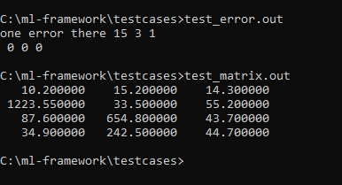

1. Vector wali baat:

Ya to row vector and column vector alag alag bnaye ya ek vector bnayege and aage jesi need us hisab se convert kr lege.

Matrix multiplication rule.

If first matrix is A*B then second one must be B*anything

Means first wale k columns second wale ki rows k equal hoga tabhi multiplication possible he.

Row vector: 1 row multiple columns (1xn)

Column vector : 1 column multiple rows (nx1)

Now vector bnane k liye phir se code bnaye ye matrix wale k upar wrap kr de.

Call forwarding : iske function ko call aayega and ye matrix k function ko call krega

Tarika no. 1: pura code naya likhe , naya struct etc.

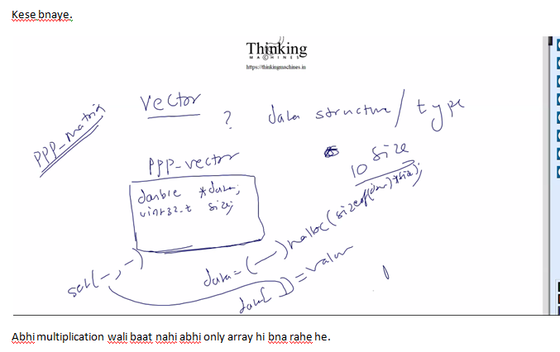

Tarika no. 2 :

Call forwarding ka use kre and bne bnaye matrix ki functionality use kr le. Like this.

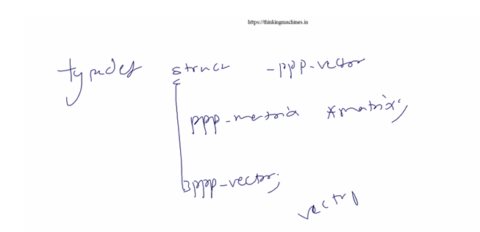

Vector struct ki only one property: pointer to matrix struct.

Isme kaha pr galat ho skta he: error messages me gdbd ho skti he kyuki isme row col nahi hote isme to size hoti he and dimesion wala koi kaam nahi.

To isko hum handle kr lege by doing some extra programming

Implementation baad me krege abhi matrix ki or hi chlte he

1. **Read data from file and fill matrix and read data from matrix and write to file or save to file**

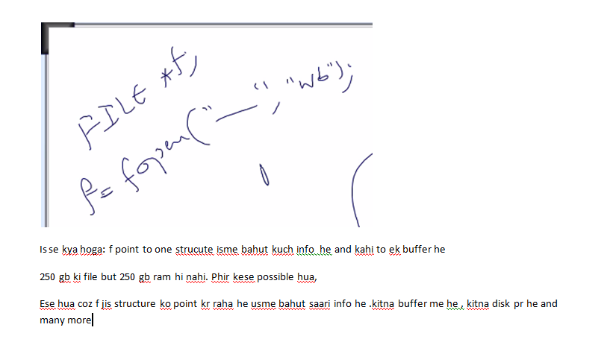

**Note:** F never point first byte of always.

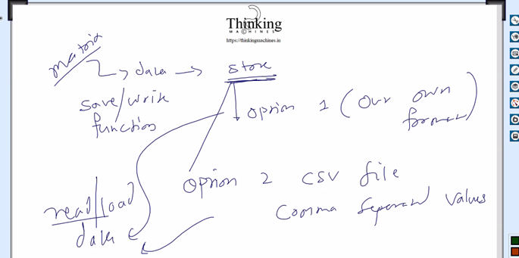

Yaha pr 2 option he format k liye, ki csv format le ya humara khud ka format bnaye

Ans: CSV lege duniya csv se hi kaam kr rahi he.

Csv me ek issue he : title line wali line

To read wale function me ek parameter extra lege jo ye btayega ki how many line to be skipped

Write k liye issue: write k liye vector of string ki jarurat pdegi, to char * ka use krege coz c me

String jesa to kuch hota nahi he.

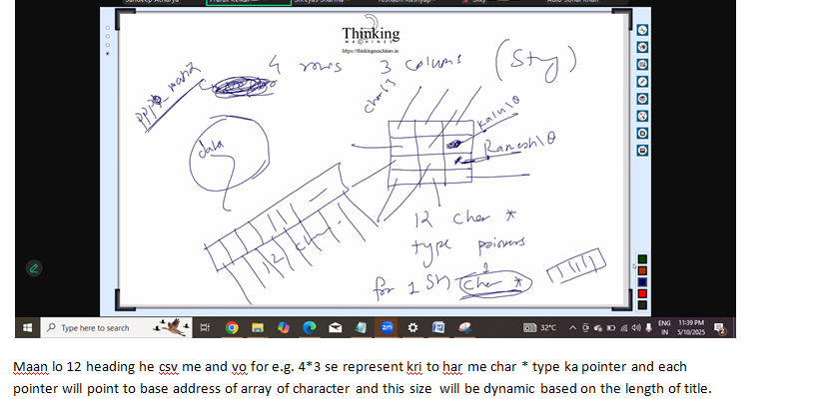

Ab humare struct ko csv me read write krne k liye matrix.h me function add hoge



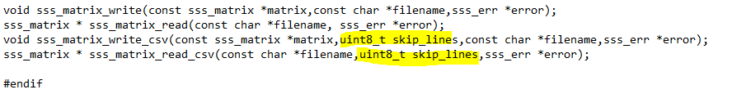

Yaha pr 2 humare format k liye and 2 function csv standard k hisab se.

Csv wale me skip_lines ki baat kri , to neglect headers, Humare example me title wali baat nahi aayegi but kahi or se file li to usme ho skti he to usko skip krne k liye ye generalize way.

Photoshop jb kuch store krta he to vo uska khud ka format hota he.

Kahi khud ka format , kahi standard.

Ab inko source file me define krte he



Before writing code lets see how we can use fwrite and fread.

Both functions take 4 parameter

1. Address of source
2. Size of chunk
3. How many chunk
4. Address of destination

Let see humara structure esa he

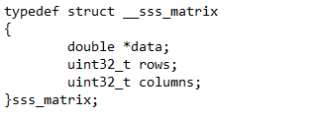

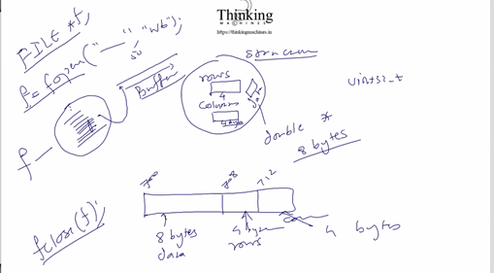

data [ pointer to double type, 8 byte ka], **iska address 700 , size of pointer depend on os**

Rows 4 byte ka, **iska address 708**

columns 4 byte ka , **iska address 712**

ab file me kya ya likhege:

1. How many rows: fwrite(**&(matrix->rows),**sizeof(uint32),**1**,f);

fwrite(708,4,1,f)

1. How many columns: fwrite(**&(matrix->columns),**sizeof(uint32),**1**,f); yaha 712 pass kiya

fwrite(712,4,1,f)

1. Then actual data: fwrite(**matrix->data,**sizeof(double),**matrix->rows*matrix->columns**,f);

fwrite(700,8,12,f) , suppose matrix is 4*3

Means matrix->data jis address ko point kr raha he memory me vaha se uthao , and sizeof(double) itna size ka chunk uthao and matrix->rows*matrix->columns itne chunks uthao and f k bharose file me likh daalo

**Isko ese bhi likh skte he:**

fwrite(**matrix->data,**sizeof(double)*matrix->rows*matrix->columns**,1**,f);

fwrite(700,96,1,f).

Means matrix->data jis address ko point kr raha he memory me vaha se uthao , and **sizeof(double)*matrix->rows*matrix->columns** itna size ka chunk uthao and 1 chunk uthao and f k bharose file me likh daalo

**Hum always niche wala use** krege , **Why?**

Iska reason he: padding , for memory alignment. Based on os

e.g: Padding means koi 8 k ghar me 5 byte ka likha to 3 ki padding lega kyuki uski capacity to ek baar me 8 pdne ki he.

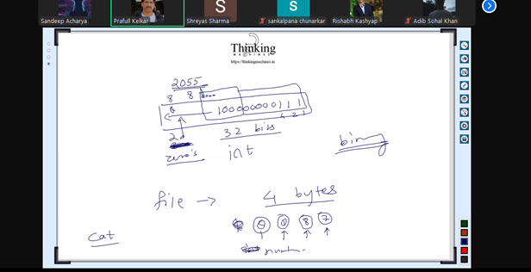

Cat file krege linux pr to esa hoga coze cat ek baar me 8 byte read krta he .



Matrix.data 96+8 = 104 byte ka and cat ek baar me 8 byte read krega to har byte se kuch or hi generate hoga.

Esa bahut si baar kisi or format ki file kisi or app se open krte he to esa dkhne ko milta he.

Abhi yaha humare format ki file read nahi kr skta. That’s why kuch to bhi print kiya he.

kyuki ek sath likhne wali baat to nahi he kahi na kahi internally buffer kaam krta hoga.because,

Ek sath to nahi likh skta he : internal architecture ki reading writing capacity k according hi likh skta he.

And kuch

Yadi humare paas int type k array ka address he in x and its size is 10 and we need to write this int array to file then how we will write



Or

fwrite(x,sizeof(int)*10,1,f);

Similarly fread works

1. **Code of sss_matrix_write & read:**

Similarly corner cases lagayege.

1. Matrix null 2. Filename null 3. File pointer null [when we open the file]

Last wale k error message me filename bhi dena rahega to uske liye hum ek char error_message lege and sprintf() ka use krke uske message copy krege and then seterror( ko error,error_message, error_code)

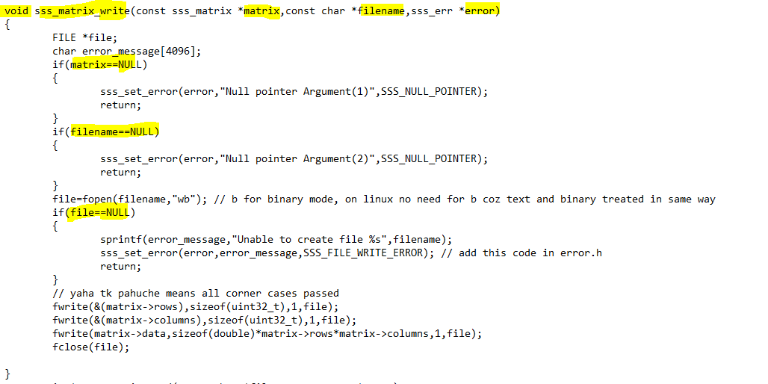

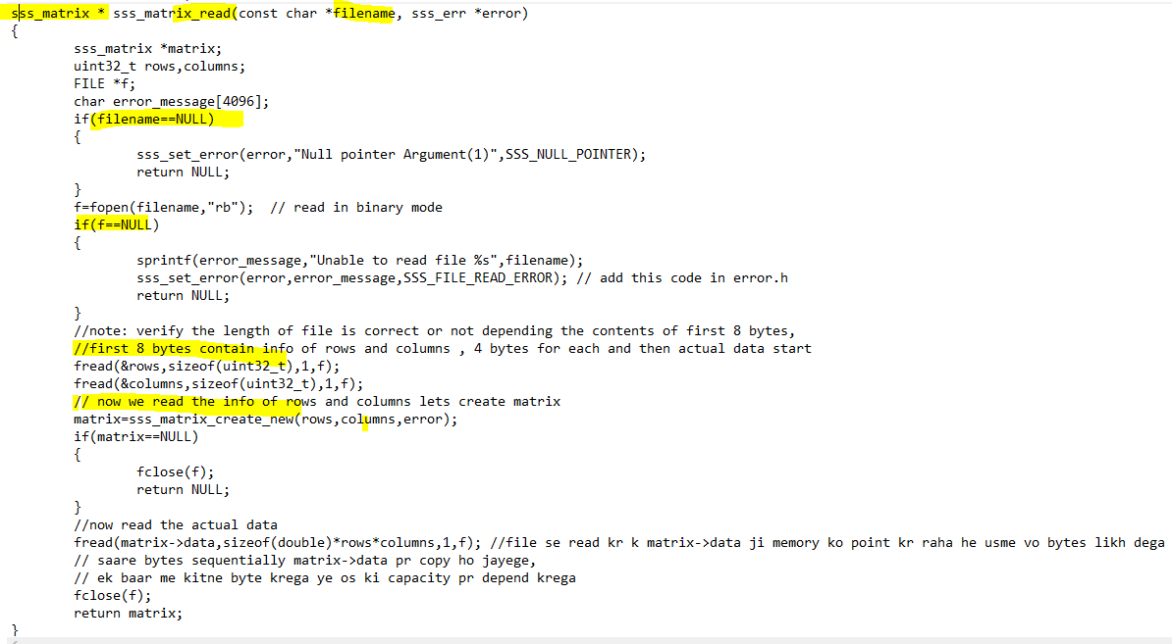

At the time of read : should we check the content of file or not .

Ya har kisi file ko martrix ka data maan k read kr le.

To hum humare format k hisab se file ko verify krege, like length of file is correct and not depending the content of first 8 bytes.

Add error code in error.h file:



Now run createlib.bat

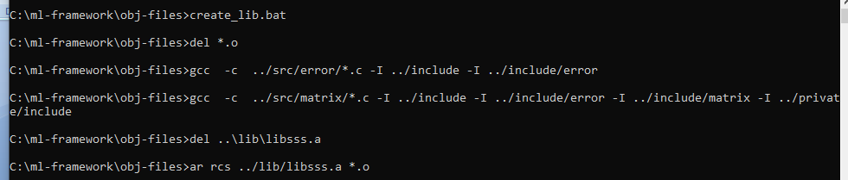

Now time to write testcase for read write matrix.

1. **Test case of sss_matrix_read and write:**



create matrix and error:

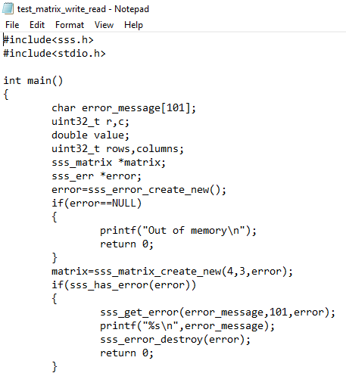

Fill matrix:

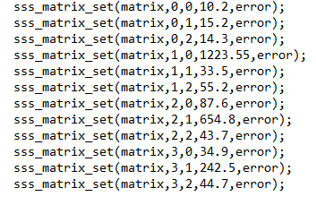

Save matrix:

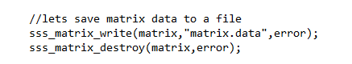

Read and print matrix

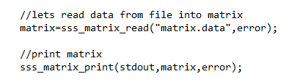

Destroy matrix and error:



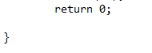

Now add line in compiletestcases.bat

test_matrix_write_read.c -I ../include -I ../include/error -I ../include/matrix -I ../private/include -I ../private/include/error -L ../lib -lsss -o test_matrix_write_read.out

now run the batch file .

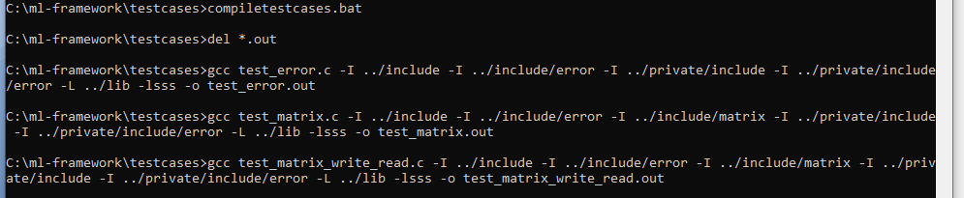

Now run the executable:

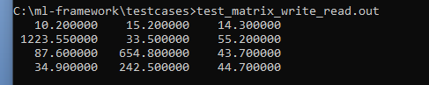

Finally we are able to write to file from matrix and read from file into matrix.

If we fire dir we can see a file matrix.data



Why its size is 104 byte?

Ans: according to our format isme 3 chize he ,

1. Row ki info, 4 byte
2. Column ki info, 4byte
3. 4*3*sizeof(double) = 96 bytes.

Total = 4+4+96 = 104 bytes.

Now: notepad matrix.data



Ye kya kuch bhi, reason

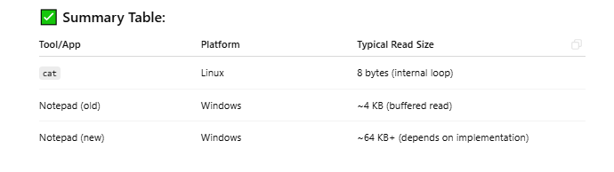

Since humara data to 1010101010….. k form me pada he, ab notepad ka kch internal hota hoga

Ki kitne byte ka chunk ek baar me uthae and us hisab se jo character bnta he vo print kr diya.

Now jo disk pr file rkhi he notepad ne usko ese represent kiya.

Coz us file k format ki info notepad k paas nahi he ki kitne byte ka chunk lena he.

Ab hum ek example ikhte he humare format ki file ko , 01010 wali ko character wali me convert krte he using frprintf()

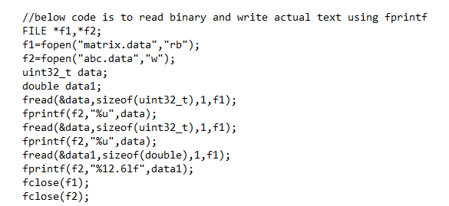

Humko pta he first k 2 chunk uint32_t size k he , then all are or double size.

See abc.data

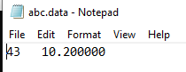

4 row 3 column first cell ka data.

To ese binary ko text me convert kiya , but hume format pta tha to humne us pattern me read kiya.

Ab next :

Ab csv file ko char array me read krege one by one byte.

CSV stands for comma separated value.

Refine part 3&4 file